Simcoe Health and Emergency Services – Dispatch Simulator

Nisha Siwach, Jay Sureshbhai Mangukiya and Akshaykumar Thakare
Department of Arts and Technology, Georgian College
AIDI 1011: AI Project
Collaboration with Simcoe County Health and Emergency Services
April 17, 2023

Problem Statement
The county's health department is seeking to leverage Al which would help improve the overall quality of service to stakeholders. As a first step, they were looking to create a dispatch call simulator for the county.
The county's health department needs to improve the overall quality of service to stakeholders by optimizing the allocation of emergency resources across different types of emergencies. In emergency situations, it is crucial to allocate the necessary resources quickly and effectively to ensure the safety and well-being of the affected population. However, manual resource allocation can be time-consuming and prone to errors, leading to delays and inefficiencies in the response.
To address this problem, the county's health department is seeking to leverage AI technology to develop a dispatch call simulator that could automate the resource allocation process. The simulator would analyze incoming emergency calls and provide reliable and useful data to allocate the necessary resources effectively across different types of emergencies. This approach would not only eliminate the need for manual allocation but also ensure a faster and more efficient response to emergencies, thereby improving the overall quality of service to stakeholders.
Objectives
General Objectives
To enhance the county's emergency response system by developing an AI-based dispatch call simulator that can automate the resource allocation process and ensure efficient and effective allocation of emergency resources across different types of emergencies. The objective is to improve the overall quality of service to stakeholders by providing timely and appropriate response to emergencies, reducing response times, and minimizing the risk of loss of life and property. The dispatch call simulator should be reliable, scalable, and adaptable to changing emergency situations, and should help the county's health department in achieving its mission of safeguarding the health and well-being of the community.

Specific Objectives
The specific objectives of the project include developing an AI-based dispatch call simulator that can automate the resource allocation process for emergency situations. The simulator should be reliable and provide useful data to ensure effective resource allocation. This would involve analyzing incoming emergency calls and identifying the type and severity of the emergency to allocate the necessary resources effectively.

The system should also be scalable and adaptable to changing emergency situations, ensuring that it can respond to different types of emergencies effectively. After the development of the system, it should be implemented and evaluated to determine its effectiveness in improving the allocation of emergency resources.

Training should be provided to relevant personnel to ensure that they can use the dispatch call simulator effectively. Lastly, the system should be continuously monitored and evaluated to identify areas for improvement and make necessary updates to the system. These specific objectives aim to achieve the overall objective of enhancing the county's emergency response system by providing efficient and effective allocation of emergency resources, minimizing the risk of loss of life and property, and improving the quality of service to stakeholders.

Methodology
Project planning
A well-defined planning process is essential for the successful execution of an AI project. Identifying current problems and defining roles and responsibilities helps ensure that the project team is aligned on the project's goals and objectives. Calculating labor and material costs provides a clear understanding of the project's budget, enabling the team to allocate resources appropriately. Creating a timeline with goals helps ensure that the project is completed on schedule and that the team is working towards the same objectives. Additionally, establishing data requirements and identifying potential roadblocks upfront can help the team avoid issues and ensure that the project stays on track. Finally, testing and iterating on the AI models being developed is crucial to ensuring that the project delivers the desired outcomes. By following a well-defined planning process, AI projects can be executed efficiently and effectively, with a focus on delivering value and achieving business objectives.

Analysis
An in-depth analysis is a critical step in the success of an AI project. This involves gathering all necessary documents and information related to the project, including any existing data sets or algorithms. Defining the features required for the project is also an important part of the analysis, as it helps to ensure that the AI models being developed will meet the project's objectives. Identifying potential roadblocks early in the process can help the project team develop contingency plans and avoid delays or compromises later on. Assessing the resources available is also crucial to the success of the project, as it helps ensure that the project can be completed within budget and on schedule. This includes evaluating the technical expertise of the team members, as well as the hardware and software resources required for the project. By conducting a thorough and comprehensive analysis at the outset of the project, the project team can gain a clear understanding of the requirements and resources needed to execute the project successfully, avoiding potential setbacks and ensuring that the project delivers the desired outcomes.

Designing
The design phase of an AI project is a critical step in the development process, as it sets the stage for how the application will function and be implemented. Defining how the application will work includes identifying the specific tasks that the AI models will perform and how they will interact with other parts of the application. Choosing the programming language is also important, as it affects the performance, scalability, and maintainability of the application. Security is a major concern in AI projects, so the design phase must also consider measures that will be taken to ensure the security of the application, such as data encryption and access control. The architecture of the application must be carefully planned to ensure that it is scalable and efficient, and the hosting platform must be chosen based on the needs of the project. By carefully considering these factors during the design phase, potential issues can be identified and addressed before the development process begins, saving time and resources in the long run. Ultimately, a well-designed AI application will be more secure, scalable, and efficient, providing the foundation for a successful project.

Implementation
The implementation phase is also a critical step in an AI project, as it involves transforming the design specifications into a functional application through programming. During this phase, the project team writes the actual code for the application and works to ensure that it is efficient and meets the project's requirements. Effective testing is also essential during this phase, as it helps identify and resolve any issues or bugs in the application. Effective communication among team members and stakeholders is also crucial during this phase to ensure that the project progresses smoothly and the application is delivered on time. Regular updates and status reports can help ensure that everyone is informed about the progress of the project and any potential issues that arise. Additionally, the team should work closely with the project's stakeholders to ensure that the application meets their needs and expectations. By conducting thorough testing and maintaining open communication, the implementation phase can be completed successfully, resulting in a functional and effective AI application.

Testing
This phase of an AI project ensures that the application is reliable, functional, and meets the project's requirements. Testing involves continuously checking each function and part of the application to ensure that they work as intended and that each part interacts well with others. By conducting thorough and systematic testing, the project team can identify and resolve any issues or bugs that may arise. It's important to test the application from multiple perspectives to ensure that it functions as intended and delivers the desired outcomes. This can include conducting performance tests, usability tests, and stress tests to identify any potential issues or vulnerabilities in the application. Thorough testing ensures that the application is reliable and meets the project's requirements, helping to avoid any unexpected issues or delays during deployment. By conducting regular testing throughout the project lifecycle, the team can identify and resolve issues early, ensuring that the final application is reliable, functional, and meets the needs of its users.

Maintenance
This phase occurs after the application has been tested and bugs have been resolved. It involves deploying the application and continually monitoring and improving it to ensure its longevity and effectiveness. Maintenance is an iterative process that includes fixing issues, improving performance, and adding new features to the application. By regularly monitoring the application and addressing any issues that arise, the project team can ensure that the application continues to meet the needs of its users and delivers the desired outcomes. Maintenance activities can include updating the application to address new security vulnerabilities, adding new functionality to the application, and improving the application's performance and usability based on user feedback. By taking a proactive approach to maintenance, the team can ensure that the application remains effective and efficient, delivering value to its users over the long term.

Data Understanding
Database | Field Name | Data Description | Data Type
ADRS (Dispatch) | CallNum | Unique Incident ID - there may be records with the same Call Num, which represent different responding vehicle on the same call | Number
ADRS (Dispatch) | CallHour | Hour that dispatcher received call - derived from [T1_CallReceived] | Number
ADRS (Dispatch) | PickupTown | Patient location municipality | String
ADRS (Dispatch) | Utm | 1km grid where patient is located known as Universal Transverse Mercator | Number
ADRS (Dispatch) | OverallProblem | Dispatcher logged reason for call at time of paramedic leaving scene or transport (T5) | String
ADRS (Dispatch) | DestinationLocationName | Indicates where the transporting unit is going - hospital, longterm care home, etc | String
ADRS (Dispatch) | DestinationCity | Destination location municipality | String
ADRS (Dispatch) | NotifyUtm | Paramedic unit's UTM location at the time of notification (T2) | Number
ADRS (Dispatch) | NotifyLowerTierDescription | Paramedic unit's municipality location at the time of notification (T2) | String
ADRS (Dispatch) | DispatchedPriority | Dispatcher call priority at the time of paramedic notification (this is based on the caller's information) | Number
ADRS (Dispatch) | OverallPriorityCode | Highest call priority at any point on the call, usually determined by paramedics at time of transport (T5) | Number
ADRS (Dispatch) | ReturnPriorityAtT5 | Dispatcher call priority at the time of paramedic transport (T5) - Determines whether lights and/or sirens are needed | Number
ADRS (Dispatch) | ReturnPriorityAtT6 | Dispatcher call priority at the time of arrival at transport destination (T6) | Number
ADRS (Dispatch) | CTAS | Paramedic determined (CTAS) Canadian Triage Acuity Scale - denotes the condition of the patient at time of Transport (T5) | Number
ADRS (Dispatch) | SCA_PT1 | Indicates if a patient experienced sudden cardiac arrest | Y/N
ADRS (Dispatch) | T0_TimeZero | DateTime when phone rings at dispatch | DTTM
ADRS (Dispatch) | T1_CallReceived | DateTime when dispatcher makes first determination of call reason | DTTM
ADRS (Dispatch) | T2_Notified | DateTime when the paramedic unit is notified of the call | DTTM
ADRS (Dispatch) | T3_Enroute | Datetime when the paramedic vehicle is enroute or "rolling" | DTTM
ADRS (Dispatch) | T4_ArrivedScene | Datetime when the paramedic vehicle arrives at the patient location (note this occurs before actual patient contact) | DTTM
ADRS (Dispatch) | T5_DepartScene | Datetime when the paramedic vehicle leaves the scene, usually indicates that a transport has occurred | DTTM
ADRS (Dispatch) | T6_ArriveDestination | Datetime when the paramedic vehicle is arriving at their transport destination - receiving facility or hospital | DTTM
ADRS (Dispatch) | PTOC | Datetime when patient transfer of care occurred | DTTM
ADRS (Dispatch) | T7_ClearDestination | Datetime when the paramedic has completed documentation, cleaning, and is now available for active service | DTTM
ADRS (Dispatch) | T11TimeCallTakingComplete | Datetime when the dispatcher is no longer on the phone with the caller | DTTM
ADRS (Dispatch) | T13_UnitCancelled | Datetime provided if the paramedic unit has been cancelled off the call | DTTM
ADRS (Dispatch) | RespondingFromStationName | Name of the station that a CSPS paramedic vehicle was responding from | String
ADRS (Dispatch) | DestinationUtm | 1km grid where paramedic unit is transporting the patient to - known as Universal Transverse Mercator | Number
ADRS (Dispatch) | FirstNotifiedUnit | Indicates if this paramedic unit was the first one notified | Y/N
ADRS (Dispatch) | FirstArrivedUnit | Indicates if this paramedic unit was the first dispatched unit to arrive on scene | Y/N
ADRS (Dispatch) | Year | Year that call occurred - Derrived from [T1_CallReceived] | Number
ADRS (Dispatch) | Month | Month that call occurred - Derrived from [T1_CallReceived] | Number
ADRS (Dispatch) | Day | Day of the month that call occurred - Derrived from [T1_CallReceived] | Number
ADRS (Dispatch) | Week | Week that call occurred - Derrived from [T1_CallReceived] | Number
ADRS (Dispatch) | Quarter | Quarter that call occurred - Derrived from [T1_CallReceived] | Number
ADRS (Dispatch) | Dispatch | Time it took the dispatcher to pickup, determine the call reason/priority and dispatch a paramedic unit ([T2_Notified] - [T0_TimeZero]) | Time
ADRS (Dispatch) | Chute | Time it took the notified paramedic unit to get enroute to the call ([T3_Enroute] - [T2_Notified]) | Time
ADRS (Dispatch) | Resp | Time it took the paramedic unit to arrive on location after notification ([T4_ArrivedScene] - [T2_Notified]) | TIme
ADRS (Dispatch) | ONSCNE | Time the paramedic unit spent on scene ([T5_DepartScene] - [T4_ArrivedScene]) | Time
ADRS (Dispatch) | INHOSP | Total time the paramedic unit spent in hospital, including offload, documentation and cleaning ([T7_ClearDestination] - [T6_ArriveDestination]) | Time
ADRS (Dispatch) | TOTALT0T7 | Total call time from dispatcher call pickup to paramedic unit back in service ([T7_ClearDestination] - [T0_TimeZero]) | Time
ADRS (Dispatch) | TOTALT0T13 | Total call time from dispatcher call pickup to paramedic unit back in service due to cancellation ([T13_UnitCancelled] - [T0_TimeZero]) | Time

Required Tools
AI classification problems require a variety of tools to be successful. One of the most important tools is a machine learning framework or library, such as TensorFlow, PyTorch, ski-kit learn, that can be used to build, train, and test machine learning models. These frameworks provide a range of pre-built algorithms and functions that can be used to classify data accurately. Additionally, data preprocessing tools, such as pandas and numpy, can be used to prepare and clean data for use in machine learning models. Visualisation tools, such as Matplotlib or Seaborn, can be used to explore and understand data and the output of the machine learning model. Finally, a suitable development environment, such as Jupyter Notebook, can be used to write and execute code, visualise data, and manage project dependencies. By using these tools in combination, developers can create effective and accurate machine learning models that can accurately classify data and provide useful insights for decision making.

Gantt Chart
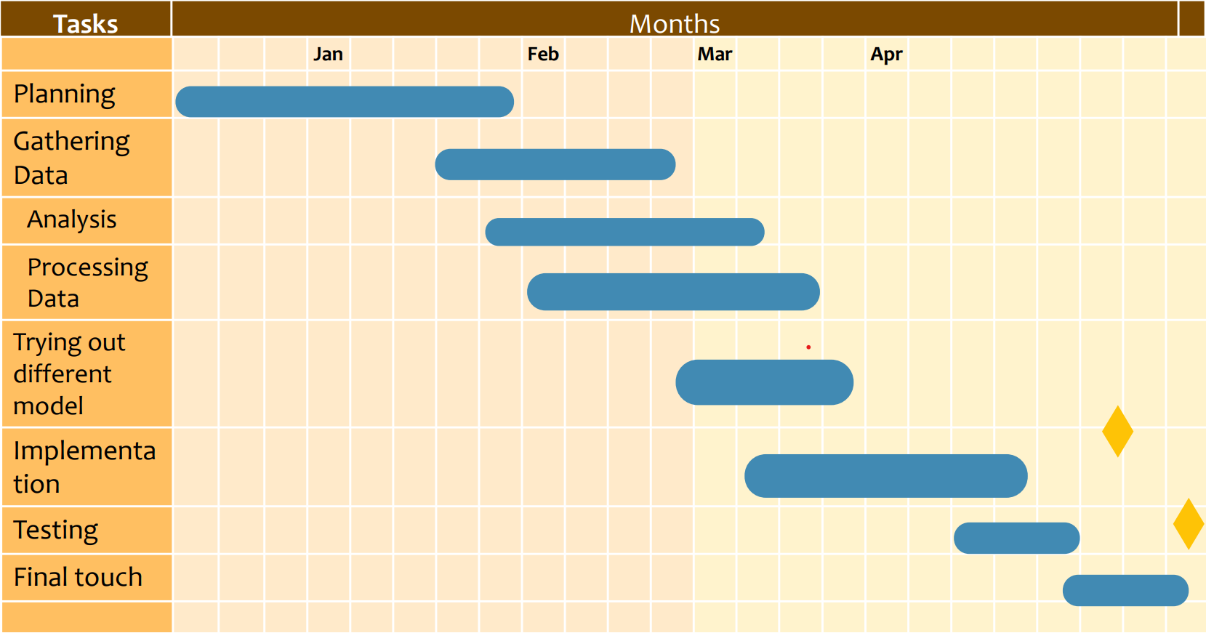
Implementation
Exploratory Data Analysis
First, we gathered the data and performed initial cleaning and preparation, such as removing duplicates, imputing missing values, and converting data types. Then, we used summary statistics, such as mean, median, and standard deviation, to describe the data and identify any patterns or anomalies.
We also used graphical methods to visualize the data and explore relationships between variables. For example, we created histograms and box plots to visualize the distribution of data and identify outliers. We also created scatter plots and correlation matrices to identify relationships between variables.

During the EDA process, we discovered several insights about the data that informed subsequent modeling and analysis. We found variables that has many nulls and outliers, which informed the selection of variables for modeling.
Overall, EDA was a critical step in our AI project as it allowed us to explore and understand the nature of the data and identify patterns, relationships, and anomalies that informed subsequent analysis and modeling.

2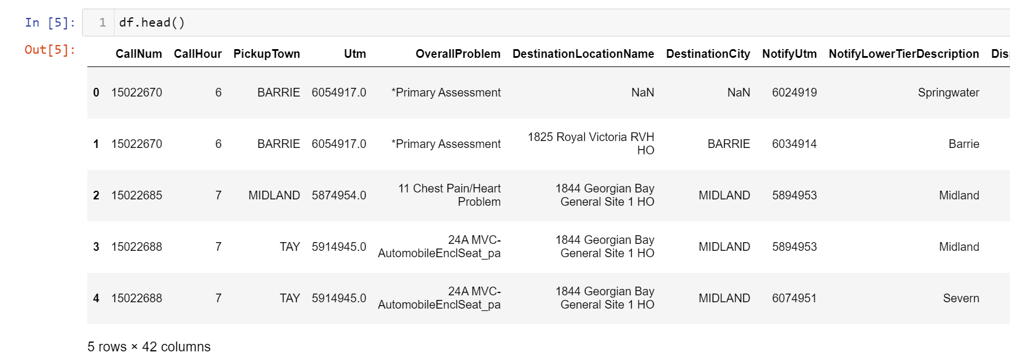
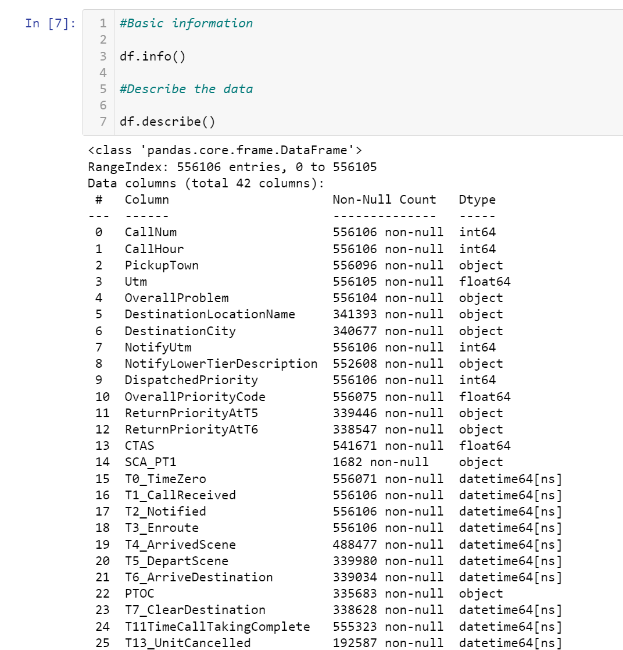

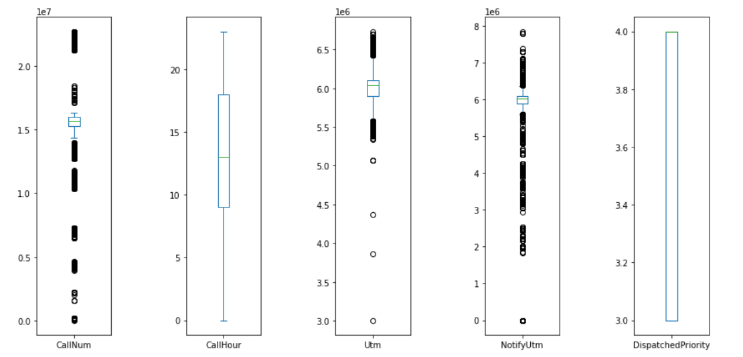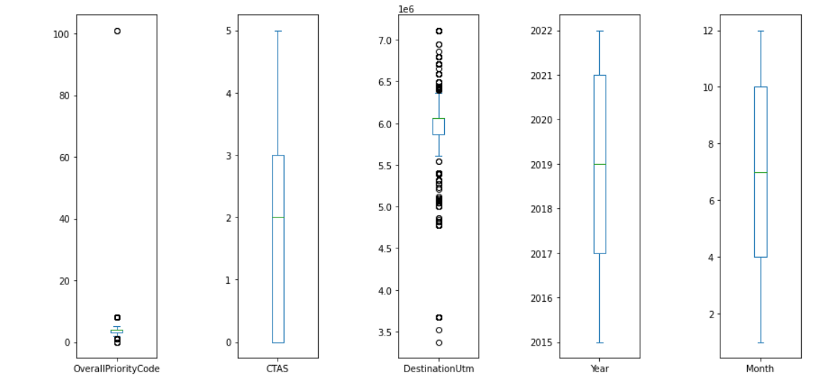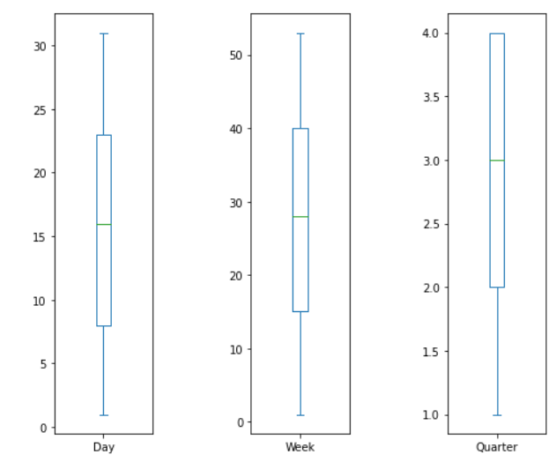

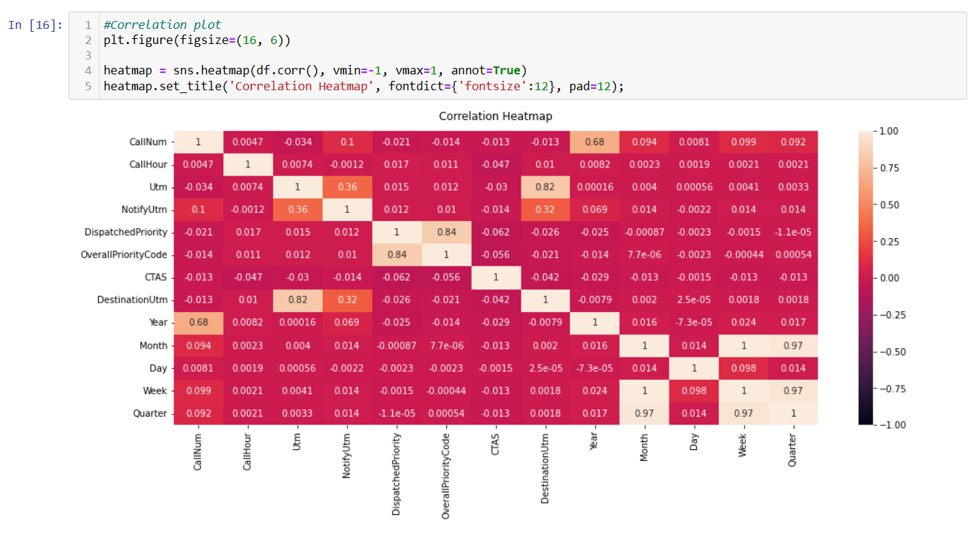
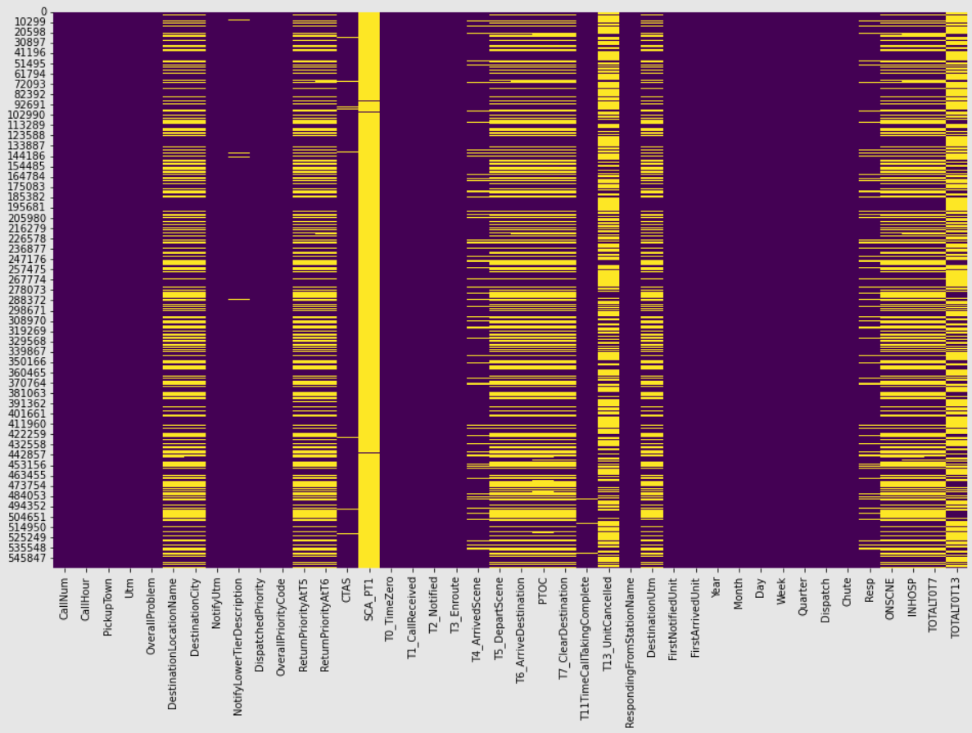

After data preprocessing and EDA, we come up with some useful insights that we will use moving forward with the Project.
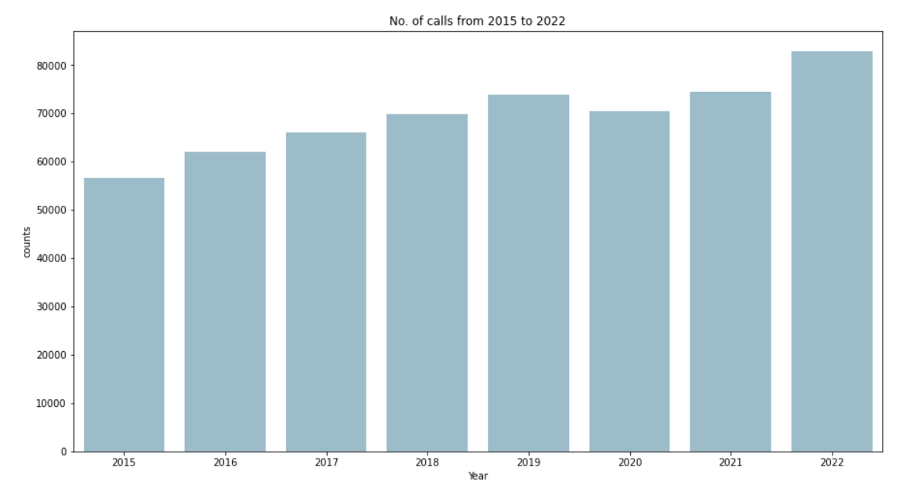
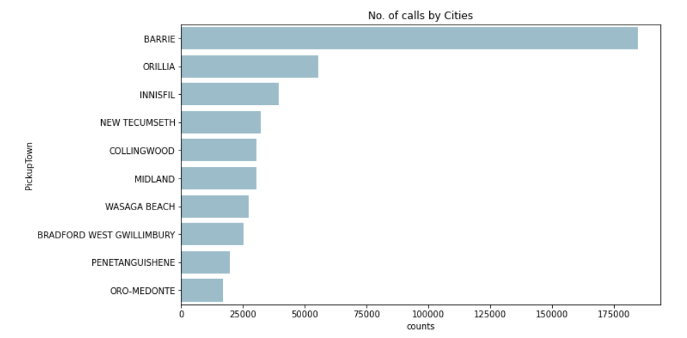

No. of call from patient that are fulfilled v/s cancelled
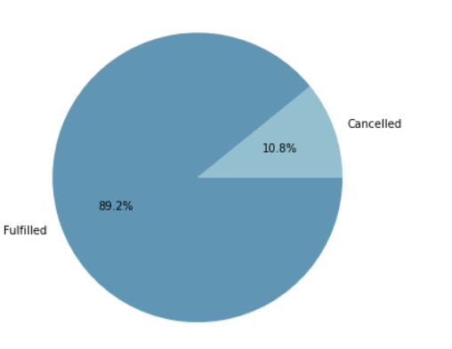
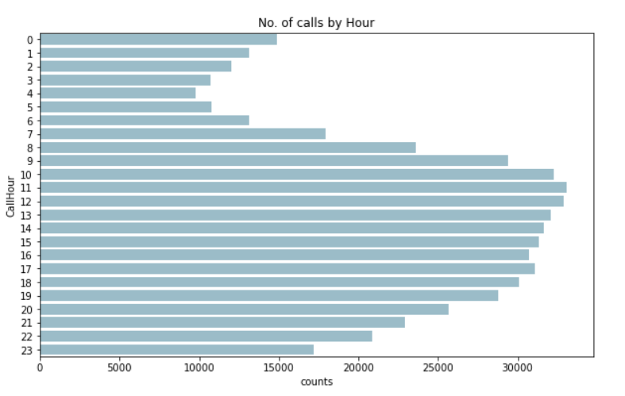

Model Development
As part of our AI project, we developed a machine learning model to predict the number of resources would be required at different stations by using abstracted features generated through feature engineering. We experimented with multiple models, including Logistic Regression, Decision Tree, Random Forest classifier, and Sequential Neural Network models, to identify the best-performing one. Our model achieved an impressive 94% accuracy on the testing dataset, demonstrating its efficacy in predicting demand.

Sequential Model
Sequential Model is a type of deep learning model that consists of a sequence of layers, with each layer passing its output as input to the next layer in the sequence. This model architecture is commonly used in natural language processing, speech recognition, and time series analysis tasks. Sequential models can be stacked with various types of layers, such as convolutional layers, recurrent layers, and dense layers, to achieve the desired level of complexity and accuracy. They are trained using backpropagation with optimization techniques such as stochastic gradient descent. We have achieved an accuracy of around 67% using this model.

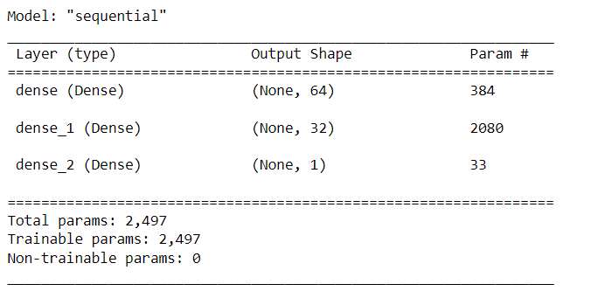

Desired Output from Sequential Model
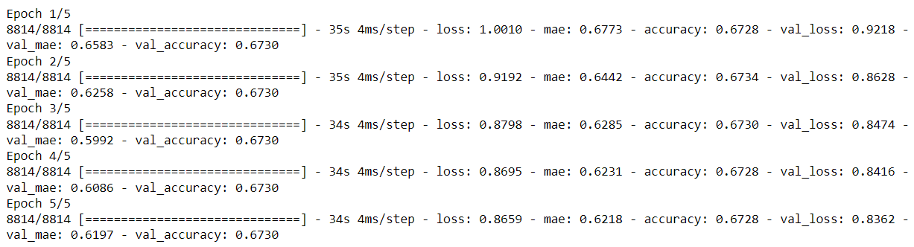
Accuracy according to this model is 67% which we feel is not that good so we decide to move with Random Forest Classifier.

Random Forest Classifier
Random Forest Classifier is an ensemble learning algorithm that combines multiple decision trees to improve the accuracy and robustness of predictions. The algorithm randomly selects a subset of features and data samples to train each decision tree in the forest, and then combines the predictions of all trees to make the final classification. This technique is effective in dealing with overfitting and noisy data, as well as handling large datasets with high dimensionality.

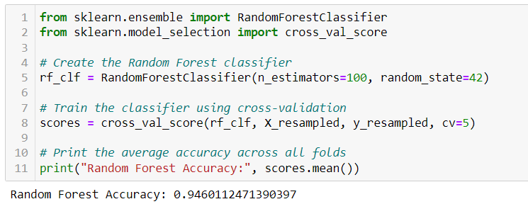
Output with Random Forest Classifier
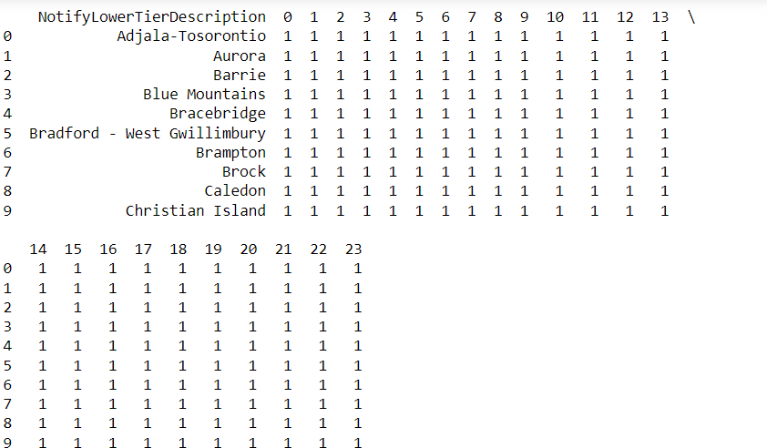

Conclusion
Simcoe Health and Emergency Services' project to create an AI-powered ambulance dispatch call simulator has the potential to significantly improve service quality. The project involves creating a data model to predict the number of ambulances needed in a particular location based on historical call data. The implementation of this technology can ensure that emergency services can deploy ambulances and personnel efficiently, providing timely access to care for patients. Throughout the project, we have followed a well-defined planning process, including analysis, design, implementation, testing, and maintenance phases. By carefully identifying current problems, defining features, assessing resources, and ensuring security, we have laid a solid foundation for this project. Thorough testing and systematic maintenance will ensure the application's longevity and effectiveness in improving ambulance dispatch services.

Challenges
During the project, our group faced a major challenge due to the limited access to data, as there were data security concerns. The available dataset had a limited sample size, which made it challenging to train the machine learning models effectively. This limited the scope of our analysis and made it difficult to generate robust insights. Additionally, the data was not uniformly distributed, which made it challenging to account for potential biases in the analysis. Despite these challenges, we made the most of the available data and used various techniques such as feature engineering and cross-validation to optimize the performance of our models. While the limited data access posed a significant challenge, we were still able to achieve an impressive accuracy rate of 94% on the testing dataset.

Future Scope
There are several potential improvements that could be made to Simcoe Health and Emergency Services' AI-powered ambulance dispatch call simulator project. One suggestion is to integrate a map to visualize the number of cases in different areas. This would allow for a more intuitive understanding of the locations with the highest demand for ambulances and enable emergency services to allocate resources accordingly. The visual representation would also help stakeholders identify patterns and trends in call volumes and better plan for future emergencies.

Another improvement could be made by integrating the model with projection growth. This would allow for more accurate predictions of future demand for ambulances and enable emergency services to prepare accordingly. By factoring in population growth and other demographic variables, projections could be made that are more reflective of the actual demand for ambulance services. This could also improve the precision of the model's predictions by reducing the effects of external factors such as pandemics or seasonal changes. Overall, these improvements could enhance the effectiveness and efficiency of the ambulance dispatch system, improving patient outcomes and resource allocation.

Deliverables with Code
Project_Implementation.ipynb: The file can include steps such as importing necessary libraries, loading data from various sources, cleaning and transforming the data, exploring and analyzing the data through visualizations and statistical measures, and finally preparing the data for machine learning models by splitting it into training and testing sets. This Jupyter notebook file serves as a comprehensive record of the entire data science process, from initial data cleaning to final data preparation for model training.
Model_Training.ipynb: A notebook file that includes the implementation of all models and testing, as well as converting the predictions into desired output would involve loading the preprocessed data, dividing the data into training and testing sets, and then implementing each of the models such as Logistic Regression, Decision Tree, Random Forest Classifier, and Sequential Neural Network. The notebook would also involve testing the models on the testing dataset and evaluating their accuracy using metrics such as confusion matrix, precision, recall, and F1 score. Finally, the notebook would include the conversion of predictions into the desired output format. The notebook should also include documentation for each step and any necessary visualizations or explanations to aid in understanding the process.
Required_Resources_Analysis.ipynb: A notebook file that contains data transformation coding would involve transforming and reshaping raw data into a format that is suitable for analysis and modeling. In this case, the data could contain information on the number of resources required and the number that were actually dispatched.

